Name: Teacher:

|  |  |  |
| --- | --- | --- |
| **Total Mark:**  **Out of 62** | **%** | **Weight**  **7.0%** |
|  |  |  |



My Target Score: _____ or _____%

MARKING GUIDE

**Time: 5 minutes reading time and 55 minutes working time.**

***MULTIPLE CHOICE:****. 20 marks*

1. In society, laws…
   1. Are rules that people live by
   2. Place limits on behaviour
   3. Apply equally to everyone
   4. All of the above
2. In Australia laws are enforced by …
   1. Police
   2. Regulators
   3. Both A & B
   4. None of the above
3. Which of the following branches of government has the power to interpret laws and how they apply to cases?
   1. Legislative
   2. Executive
   3. Judiciary
   4. Parliament
4. The adversary system originated in…
   1. Australia
   2. Britain
   3. United States of America
   4. China
5. Which of the following is not a synonym of adversary?
   1. Rival
   2. Friend
   3. Enemy
   4. Opponent
6. True or False: Each side in the adversary system has control over their own argument.
   1. True
   2. False
7. Public law… *not the best MC question you could accept both
   1. Includes rules made to control the public
   2. Affect society as a whole
   3. Deals with disputes between individuals
   4. Only applies to people who live in cities
8. Private law…
   1. Includes rules made to control the public
   2. Affect society as a whole
   3. Deals with disputes between individuals
   4. Only applies to people who live in cities
9. Which of the following is not classified as Private law?
   1. Civil Law
   2. Trading Law
   3. Church Law
   4. Criminal Law
10. Australia’s legal system consists of certain basic principles that try to protect members of society and ensure justice is done… this is known as…
    1. The Universal Declaration of Human Rights
    2. Separation of Powers
    3. The Rule of Law
    4. Open Justice
11. The Rule of Law has many effects on society… with the rule of law which of the following does not occur?
    1. Equality before the law
    2. Right to assembly
    3. Anarchy
    4. Fair Trial
12. There are 3 rules of evidence, which one relates to rumours and gossip?
    1. Relevance
    2. Hearsay
    3. Legality
13. Who has control over the courtroom?
    1. Judge
    2. Jury
    3. Orderly
    4. Prosecution
14. True or False: Judges are not expected to be independent from the government as they are appointed by parliament.
    1. True
    2. False
15. The role of the jury is to…
    1. Decide the verdict of the case
    2. Decide the verdict and the sentencing
    3. Decide if the case should go to trial
    4. None of the above
16. Which Western Australian court can hear criminal cases for which the maximum penalty is life imprisonment?
    1. Magistrates Court of Western Australia
    2. Coroners Court
    3. Supreme Court of Western Australia
    4. District Court of Western Australia
17. Which of the following is NOT a feature of the Australian legal system?
    1. All persons are considered innocent until proven guilty
    2. The power of the government is divided between the judiciary, executive and legislature
    3. All persons are equal before the law
    4. The decisions of all the courts are final and cannot be challenge
18. In a criminal case the right to a fair trial, means that the trial must be fair to who?
    1. The defendant
    2. The victim
    3. Witnesses
    4. All of the above
19. How many people serve on a jury?
    1. 21
    2. 12
    3. 10
    4. 13
20. A person who brings a case against another in court in known as
    1. Defendant
    2. Plaintiff
    3. Defence
    4. Offence

***Short Answer***

1. Define the following terms and provide an example. (6 marks)
2. Public Law

* *1 mark for a correct definition (law that affects society as a whole)*
* *1 mark for an appropriate example (criminal law etc)*
* *1 mark for a well-structured answer (syntax etc)*

1. Private Law

* *1 mark for a correct definition (law that relates to disputes between individuals)*
* *1 mark for an appropriate example (civil law etc)*
* *1 mark for a well-structured answer (syntax etc)*

1. Describe how the adversary system works. A good answer will include examples. (4 marks)

* *1 mark for a correct description of the adversary system (e.g. a legal system where two parties present their opposing positions to a jury or judge)*
* *1 mark Mentions in civil cases = plaintiff and defendant*
* *1 mark in Criminal Cases = Prosecution and Accused*
* *1 mark for a well-structured answer that follows the action word*

1. Looking at the diagram, state the name of the person/role as indicated by the letter. (4 marks)

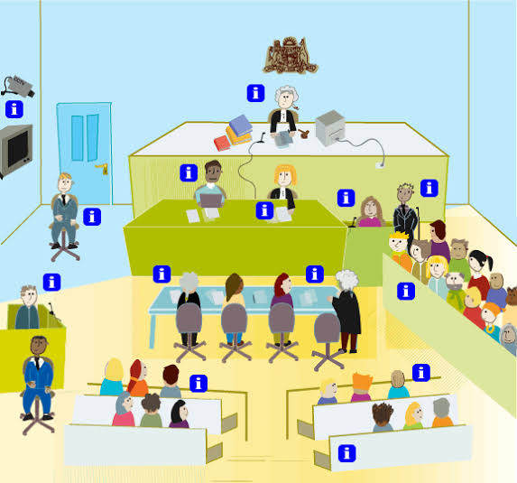

**A**

**B**

**C**

**D**

1. *Judge*
2. *Jury*
3. *Orderly*
4. *Members of the Public*
5. Classify each of the following as whether they occur with or without the rule of law by ticking the appropriate column. (6 marks)

|  |  |  |
| --- | --- | --- |
|  | **With the Rule of Law** | **Without the Rule of Law** |
| Forced confessions |  | **✔** |
| Right to silence | **✔** |  |
| Presumption of innocence | **✔** |  |
| Freedom of speech/media | **✔** |  |
| Presumed guilty or punished without a trial |  | **✔** |
| Public gatherings are banned |  | **✔** |

1. For each of the civil cases scenarios below, match the outcome that correctly results by drawing a line between them. (3 marks)

|  |  |  |
| --- | --- | --- |
| Defendant Wins |  | Defendant provides greater evidence against the allegation the plaintiff provides to support it. |
| Plaintiff Wins | Plaintiff does not produce enough evidence to support their allegation. |
| Defendant Wins | Plaintiff provides greater evidence than the defendant – enough to support their allegation on the balance of probabilities |

1. Select one of the following principles and explain how it contributes to ensuring everyone is treated fairly, equally and that justice is maintained. (5 marks)
2. Open to Justice
3. Burden of Proof
4. Access to Justice
5. Innocent until proven guilty

*will depend on which principle the student chooses

* *1 mark for a selection of one of the principles and an appropriate definition of what it means*
* *1 mark for an appropriate explanation of how it ensures everyone is treated fairly/equally*
* *1 mark for an appropriate explanation of how it ensures justice is maintained*
* *1 mark for an appropriate example*
* *1 mark for a well-structured answer that follows the action word*

1. *Open Justice – belief that justice should not only be done, but justice should be seen to be done, justice should not be carried out behind closed doors, anyone should be able to enter a courtroom and view the proceedings*
2. *Burden of Proof – the complainant (plaintiff) must prove beyond reasonable doubt that the accused is guilty*
3. *Access to Justice – justice should be available to everyone, not just those who can afford expensive legal fees, sources of legal help exist for people who cannot afford legal representation, eg legal aid*
4. *Innocent until proven guilty – no guilt can be presumed until the charge has been proved beyond reasonable doubt*
5. Define the term referendum. Use an example to support your definition. (3 marks)

* *1 mark for a correct definition ( a vote of the Australian electors on a proposed change to the Australian Constitution)*
* *1 mark for an appropriate example*
* *1 mark for a well-structured answer (syntax etc)*

1. State how many referendums have been held in Australia’s history. (1 mark)

*44 referendums*

1. State how many successful referendums there has been in Australia’s history. (1 mark)
   * 1. *referendums*
2. Describe what must happen in a referendum for a “Double majority” to occur. (3 marks)

* *1 mark for a description of a majority (more than half of the total number) – exactly ½ is not enough and a double majority is needed to change the constitution*
* *1 mark for each correct description of what must occur for a double majority to occur*
  + - * *A total ‘yes;’ vote across Australia needs to be more than 50%*
      * *There has to be a majority of ‘yes’ votes in more than half of the states, this means at least 4 states have to vote yes*
* *1 mark for a well-structured answer that follows the action word*

1. For a referendum you have studied, answer the questions below:
2. State the Name and Year of a Referendum you have studied. (2 marks)

*This will depend on the student’s individual response e.g. 1967 Referendum or 1999 referendum*

1. Outline what this referendum was about and outline the outcome of the referendum.

(4 marks)

*this will depend on student’s answer to question 1

* *1 mark for an appropriate outline of what the referendum was about, the issue that was addressed etc*
* *1 mark for an appropriate outline of the outcome of the referendum (was it successful or not, links to a double majority.*
* *1 mark for mentioning data or statistics relating to the outcome*
* *1 mark for a well-structured answer that follows the action word*